American Heart Association (AHA) BLS cards

Please send a copy of your current American Heart Association BLS, ACLS, and/or PALS card(s) to your Recruiter the Wednesday prior to start date.

***If you do not have an active, unexpired AHA BLS Provider certification, please contact recruiter asap.***

Link: [How to Claim and View your AHA eCard](https://cpr.heart.org/en/resources/faqs/how-to-claim-and-view-your-aha-ecard)

Cards should look like this.

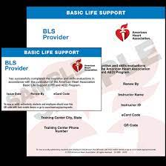 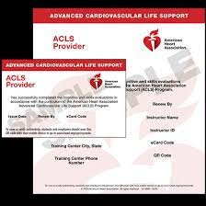 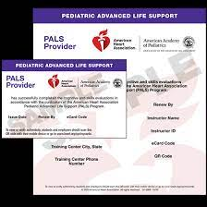

***If you need to schedule a class, please take the class by end of day on Wednesday before your start date!***

Athens CPR is familiar with our requirements: 706-549-5882. Please remember to only take the AHA BLS class. All other CPR classes are not approved.

-OR-

Find classes & more information:

<https://cpr.heart.org/en/cpr-courses-and-kits/healthcare-professional/basic-life-support-bls-training>